Городская олимпиада школьников по английскому языку.
2017-2018 учебный год.
Задания для учащихся 2 класса. ШИФР:_____________________

Задание 1. Послушай и напиши.

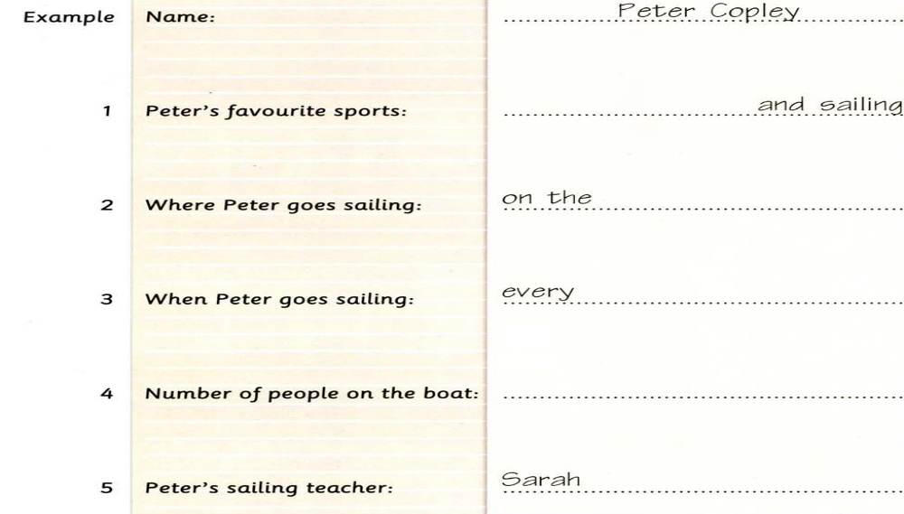

Задание 2. Послушай и выбери картинку.

What`s Bob looking at? 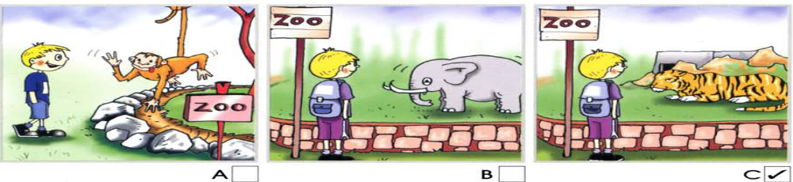
1)What`s Anne doing?
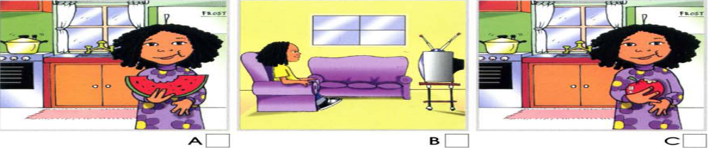
2)Where`s Tom?
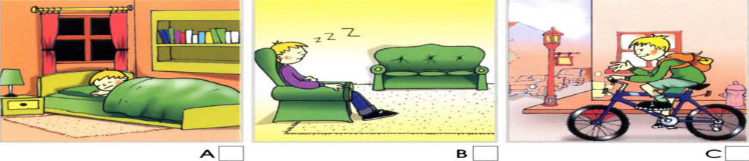

3)Where are Paul and Joe?
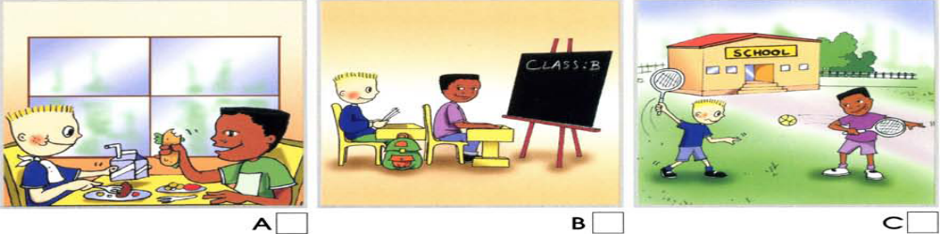
4)What`s Mary playing with?
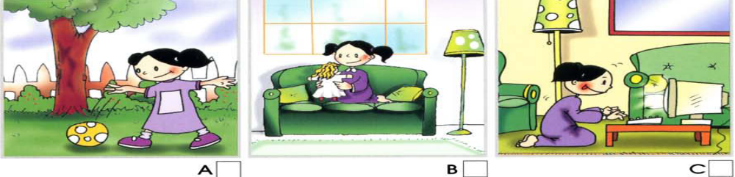
5)What`s dad doing?
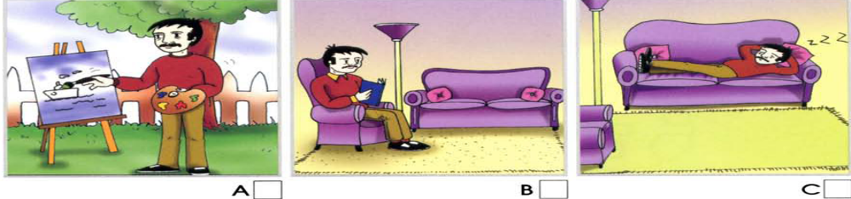

Задание 3. Прочитай текст и впиши правильное слово.
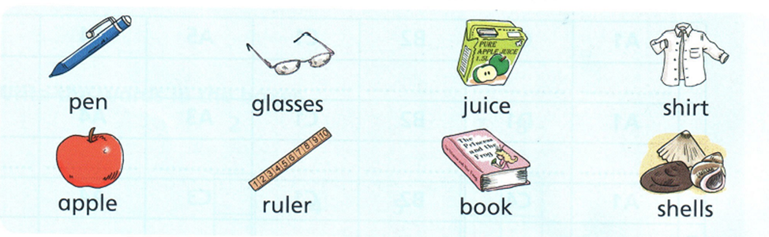
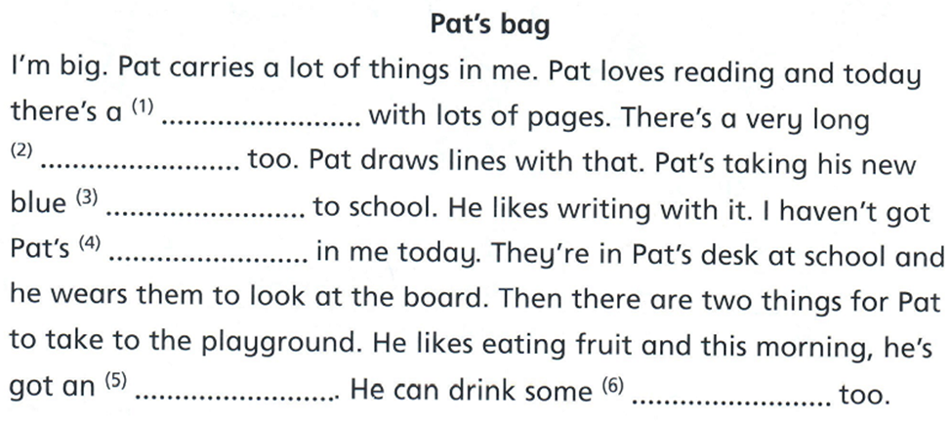

Задание 4. Прочитай текст снова. Отметь, соответстуют ли утверждения тексту. True – правильно. False – неправильно.

- There are few pages in the book. True/ False
- Pat draws lines with an eraser. True/ False
- Pat's new pen is blue. True/ False
- There are no glasses in Pat's bag. True/ False
- Pat likes eating sandwiches in the morning. True/ False
- There is some juice in Pat's bag. True/ False

Задание 5. Прочитай текст, вставь в пропуски правильное слово из предложенных ниже.

This 1) is my pet dog!
2) ____________ name is Benjy. He is brown. He 3) _________ got a big body and 4) ______long tail. His ears 5) _________ long, too! He's got big, white 6) ___________ and brown eyes. Benjy 7) _________ swim and jump, but he 8) __________ climb a tree.
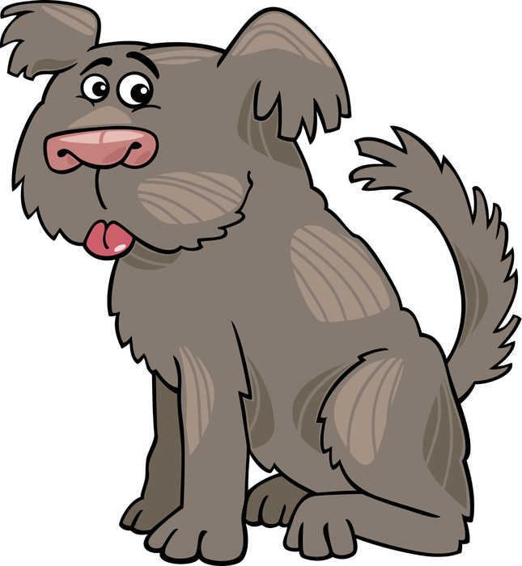
1) is am 5) are is
2) Their His 6) tooth teeth
3) have has 7) has can
4) a an 8) isn't can't

Задание 6. Прочитайте загадки и выберите правильное слово.

1. You can eat this food in a sandwich.
2. You wear these when you play sports.
3. You can ride this animal.
4. You find this in a bathroom or in a bedroom.
5. There are a lot of trees and animals in this place.

clock | forest | trainers
mirror | cheese | horse

